# 

**Listening Campaign**

We will be hosting a Listening Campaign for our K0-6th grade families. The Listening Campaign is an opportunity for us to hear from our families as they share their ideas and concerns about the school. This forum will help us to better understand the needs of all the families we serve at the Roosevelt and help to promote family voice while creating a connection for both families and the school to share their unique experiences. Listening sessions will be held on Tuesday, October 27th from 6:00-7:30 p.m. and Saturday, November 7th from 10:00-11:30 a.m.

**Save the Date**

**Walk4Kids October 30th**

Pledge sheets are coming home with your child/ren this week.

**K2 Update**

The kindergarten students have been very busy. We have shared out Hope and Dreams for kindergarten and learned the importance of our Buddy Bench. Some of the Activities we have done during our Center Time, include, color mixing, acting out the story, Abiyoyo, building communities in the Block Area, and reading our friends names. In math we have been exploring the many math materials we will use this year, counting people, sorting and learning the names of shapes. We look forward to a great year!! 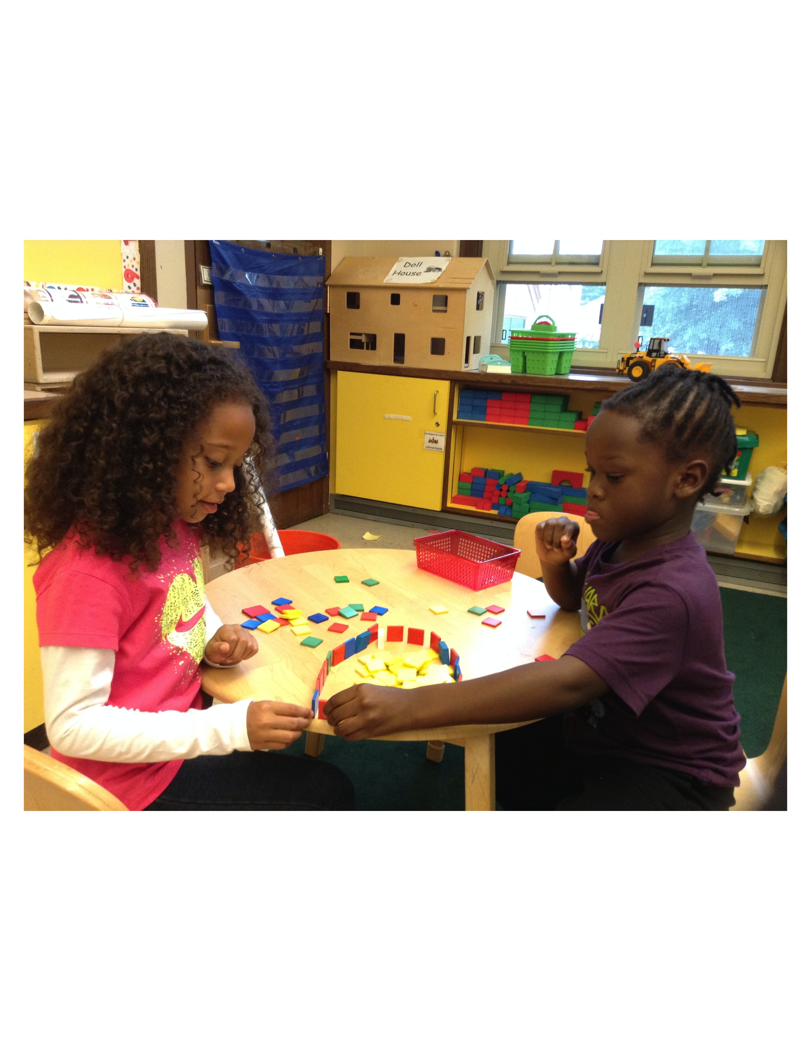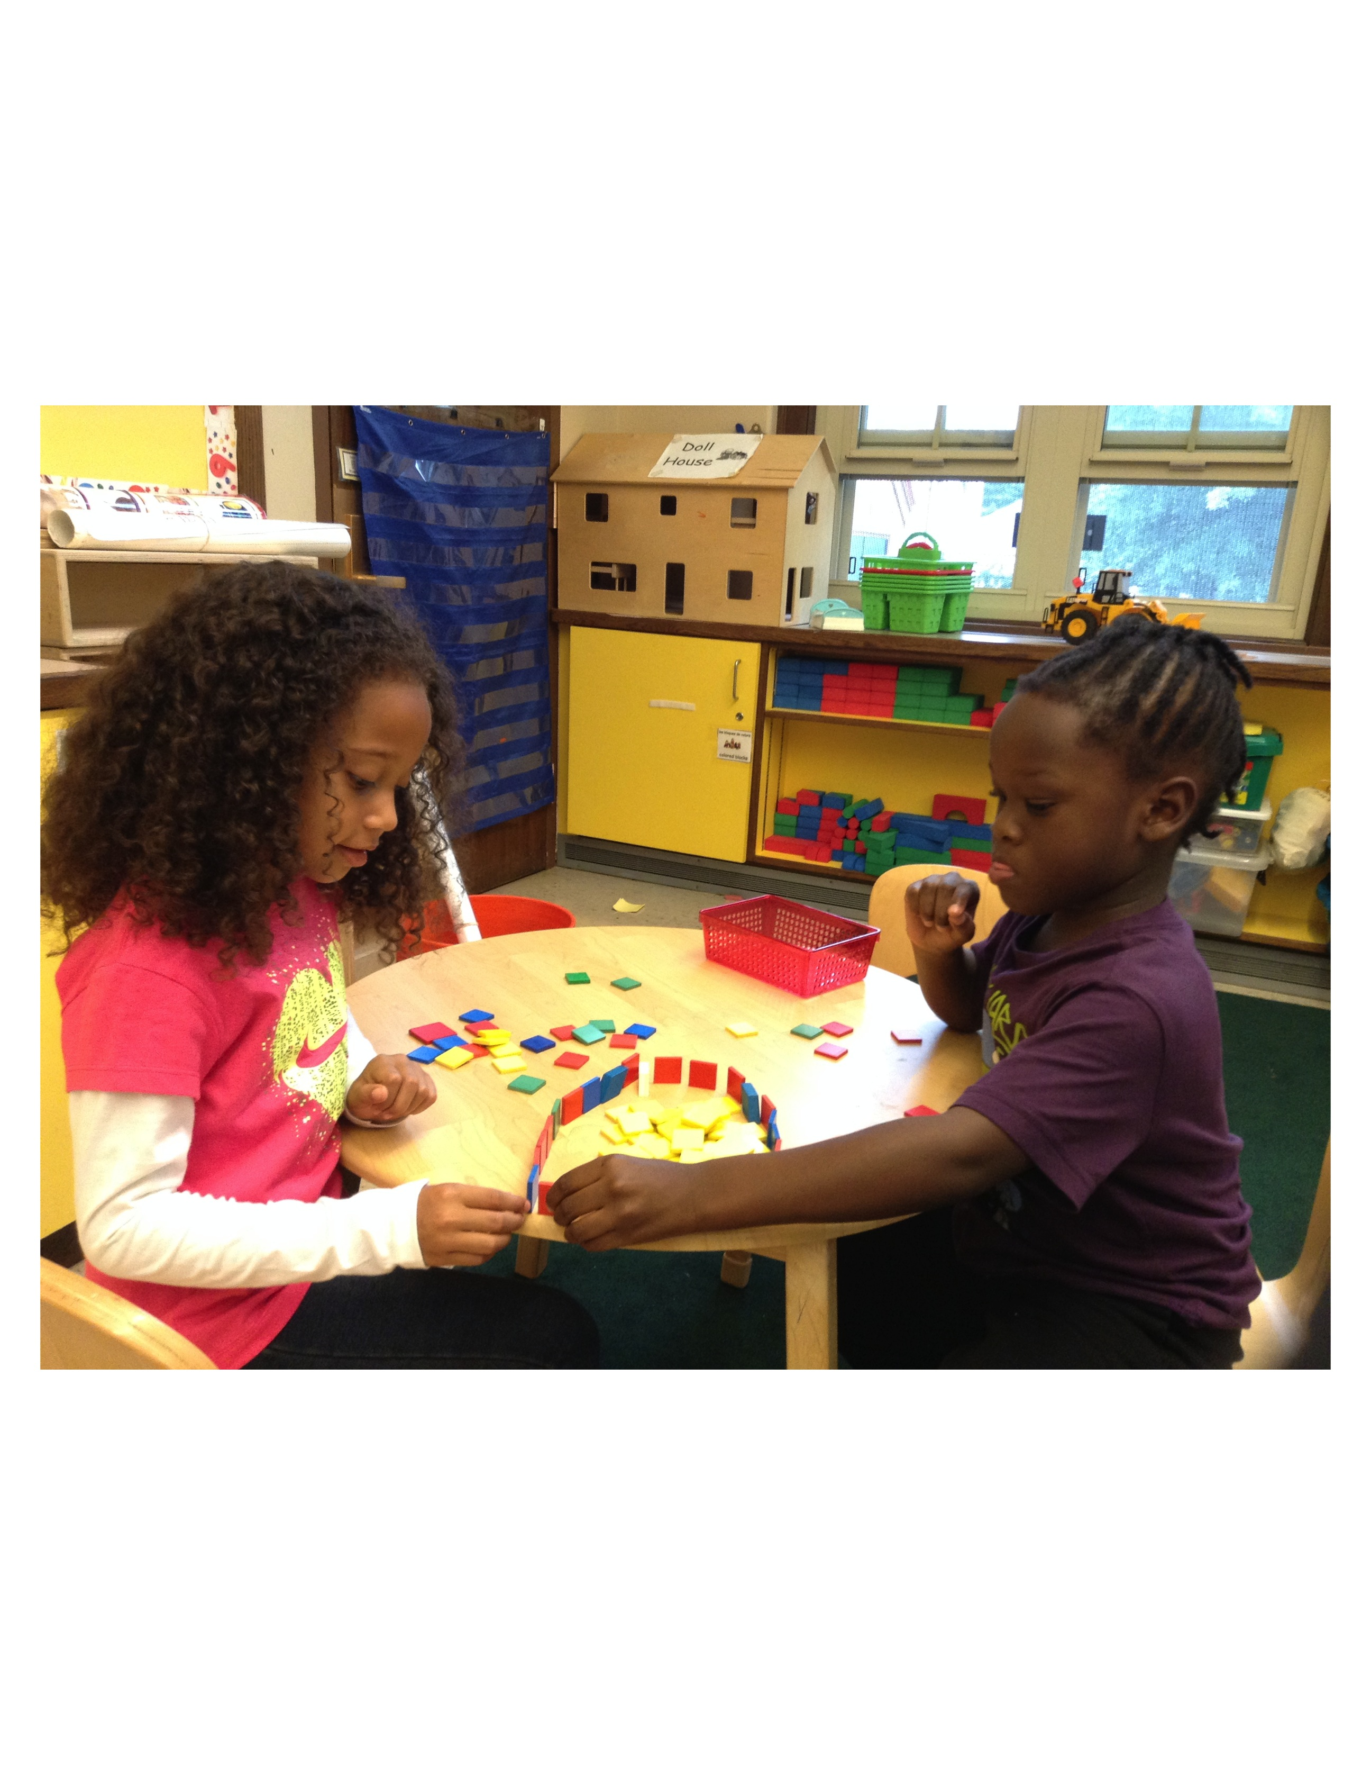

**Lower Campus Community Celebration**

Congratulations to the following students who received recognition for demonstrating our core value of Responsibility Top (l-r) Elisabeth B., David W, Thomas C, Annabel

Bottome (l-r) Vernon, Caelan, Willm, Alexxa

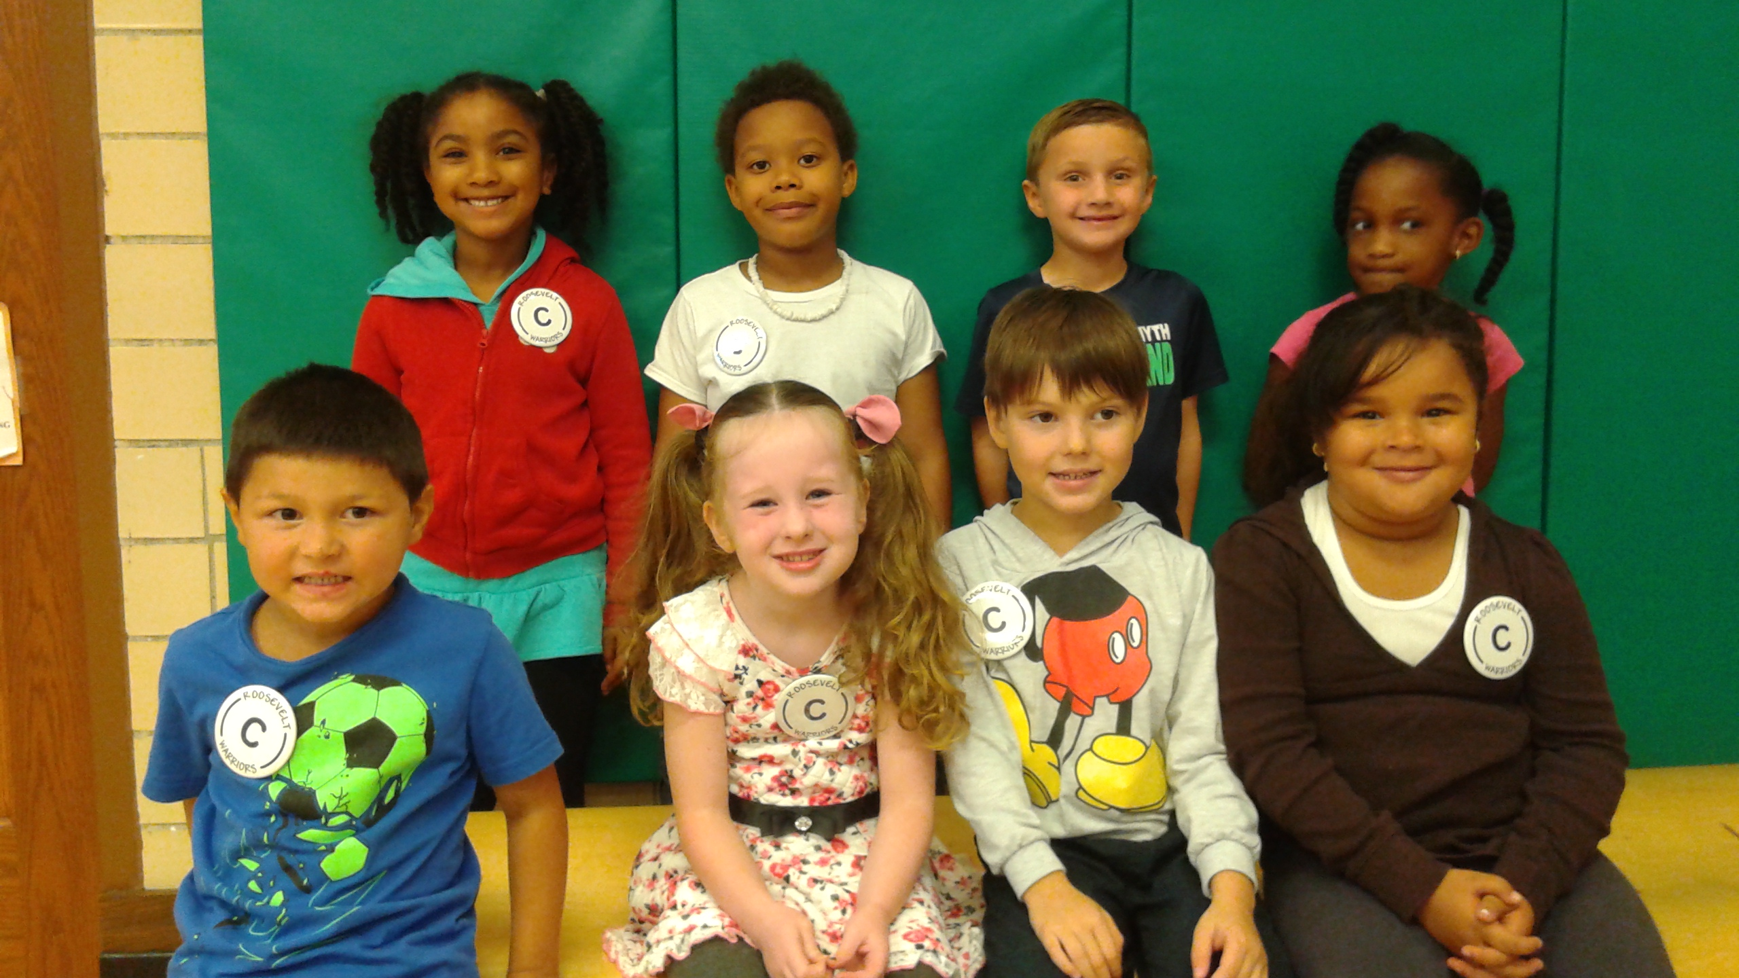

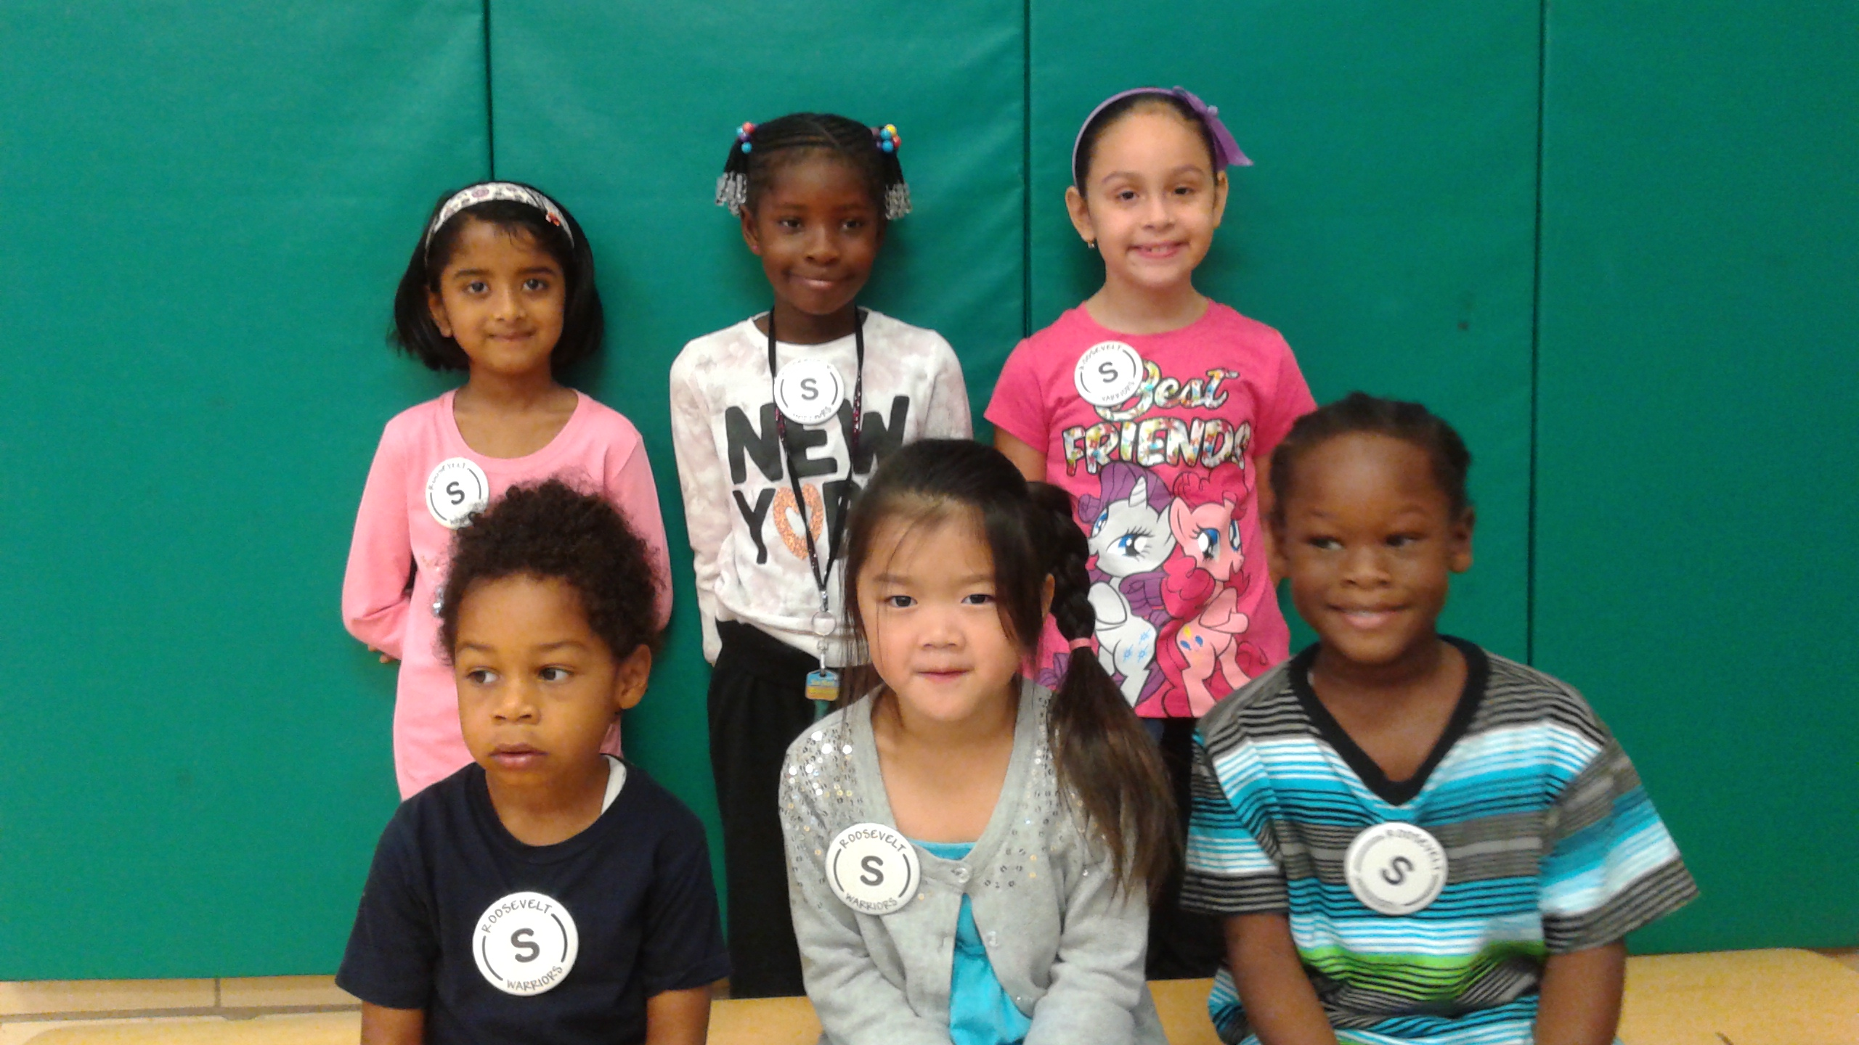

Congratulations to our Lower Campus Scholars for the month of September!L-r Back Jenseen J (K2) Giada (1) Amaryllis (1)L-r front Lewis (k1) Alison (k1) and Jabari(k2)

**Grade 7-8 ELA Update**

Over the course of October 7th and 8th grade English classes will focus their efforts on learning how to engage in effective classroom discussions using a variety of texts.  Students will be explicitly taught norms and procedures that help them discuss topic respectfully, while building on the thinking of their group members.  As well, at the end of every month, students in 7th and 8th grades will complete projects based on their independently selected novels.  Ms. Beaulieu and Mrs. Feaster were very pleased with the letters that students wrote about their first novels!  We were most impressed by the way students gave each other very specific feedback on how to improve upon their writing during class, and then how students went back and made great revisions to their final copies.  So far we’re off to a great start!  We can’t wait to see the book brochures students complete by the end of October!

**Middle School Math News!**

Welcome! The 8th graders are already hard at work on their algebraic thinking. They have begun the work of inventing number tricks and representing them with an algebraic expressions, and of using scientific notation to express very large and very small numbers.



**C:\Users\126543\AppData\Local\Microsoft\Windows\Temporary Internet Files\Content.IE5\T3Z8FKF3\MC900384132[1].wmf**

Franklin D. Roosevelt School

Big Time News- October 8, 2015

**Mixed Bags Fundraiser**

Have you seen the fantastic products offered in both the Bags & Accessories and Kitchen & Home Catalogs? They have something for everyone and are also good for the environment.  
The kids can earn prizes for orders including a tablet! Check out the letter that came with the catalog for more details.

Remember **you can have out of state/area family and friends support us too by participating online with our fundraiser ID - 315000.** Have everyone else order from your catalog!  Please have all orders in to your child's homeroom teacher by October 14th!   Thanks in advance for your support!

**SSC and SPC Elections**

School Parent Council (SPC) and School Site Council (SSC) elections will be held on Wednesday October 14th from 6:15pm-7:30pm at upper campus library facilitated by Karla Jenkins. In conjunction with the family engagement office, there will be childcare and light refreshments offered.  
All parents and legal guardians of a child(ren) enrolled at the Roosevelt are automatically members of the SPC.  The role of the SPC includes, but is not limited to:  
-Collaborating with school staff to create welcoming school climate, Coordinating school-wide activities and events, and Engaging families in student learning  
-Providing a safe forum for families to express concerns  
-Contributing to school-based initiatives related to school improvement, school climate and student learning.  
-Raising funds to support school-based initiatives, activities and events  
The Executive Board is comprised of up to 6 parents and legal guardians who elect to serve as either co-chair, treasurer or a secretary.  
Should you have any interest or questions regarding the upcoming election please contact Lori McElmoyle ([ltmcelmoyle96@gmail.com](mailto:ltmcelmoyle96@gmail.com))  
The SSC is the governing body of the Roosevelt that participates in school-based decision making.  This Counsel consists of faculty and parents/legal guardians.   Communication between both the SPC and SSC is facilitated.

**"Watch Us Grow"**

The Lower Campus is very excited that the work on our Outdoor classroom has begun.  Our learning space is growing into the outdoors!  In the past two weeks, we have laid down raised garden beds, covered a meeting area in stone dust, set up some bird feeders and planted butterfly bushes.  This week, we also planted bulbs, perennials and trees.  We have also added tables, easels, logs for seating, a bird feeder and bird bath to the outdoor classroom area.  The entire area will also get mulched and paving stones will be set down to make a path for our students.  Our project is being supported by Blue Hills Bank, Central Hardware and Hyde Park Masonry.   Thank you also to the Kurpeski’s (Robert is in K2) and Right Price Carpentry who supplied materials and labor.  Thank you to all of the parents who have volunteered to make this project a reality:  Jammie Carty (daughters Allison and Kaleigh are in K1 and K2, John in Grade1) Brian James (sons Thomas and Tyler are in K1 and K2) Rosemarie Munroe (sons Jonathan and Jabari are in 1st grade and K2), Donnet Bryant (son Alex in K1), Joe Maalouf (daughter Gigi in K2) and Amy Boudreau (son Will in K1).

We will have a ribbon cutting in the near future.  We will keep you posted on the progress.

**Day of Service**

On Friday, September 25th Students at the school took part in the very first **Green Apple Day of Service**. Green Apple Day of Service helps to bring together our students and teachers at the school to improve our school environments through service projects around our classrooms, the school the neighborhood and community events. Our Roosevelt champions demonstrated their passion for our environment and strength to take action at our schools. It was exciting to various classes working to removing weeds from the green roof, clearing and freshening up the grounds around the raised vegetable garden, beginning the clean-up of the playground, clearing litter from the park and removing trash along the streets of our school for Green Apple.

Congratulations to ALL the teachers and students that discussed the importance of service and/or took action and completed some service.[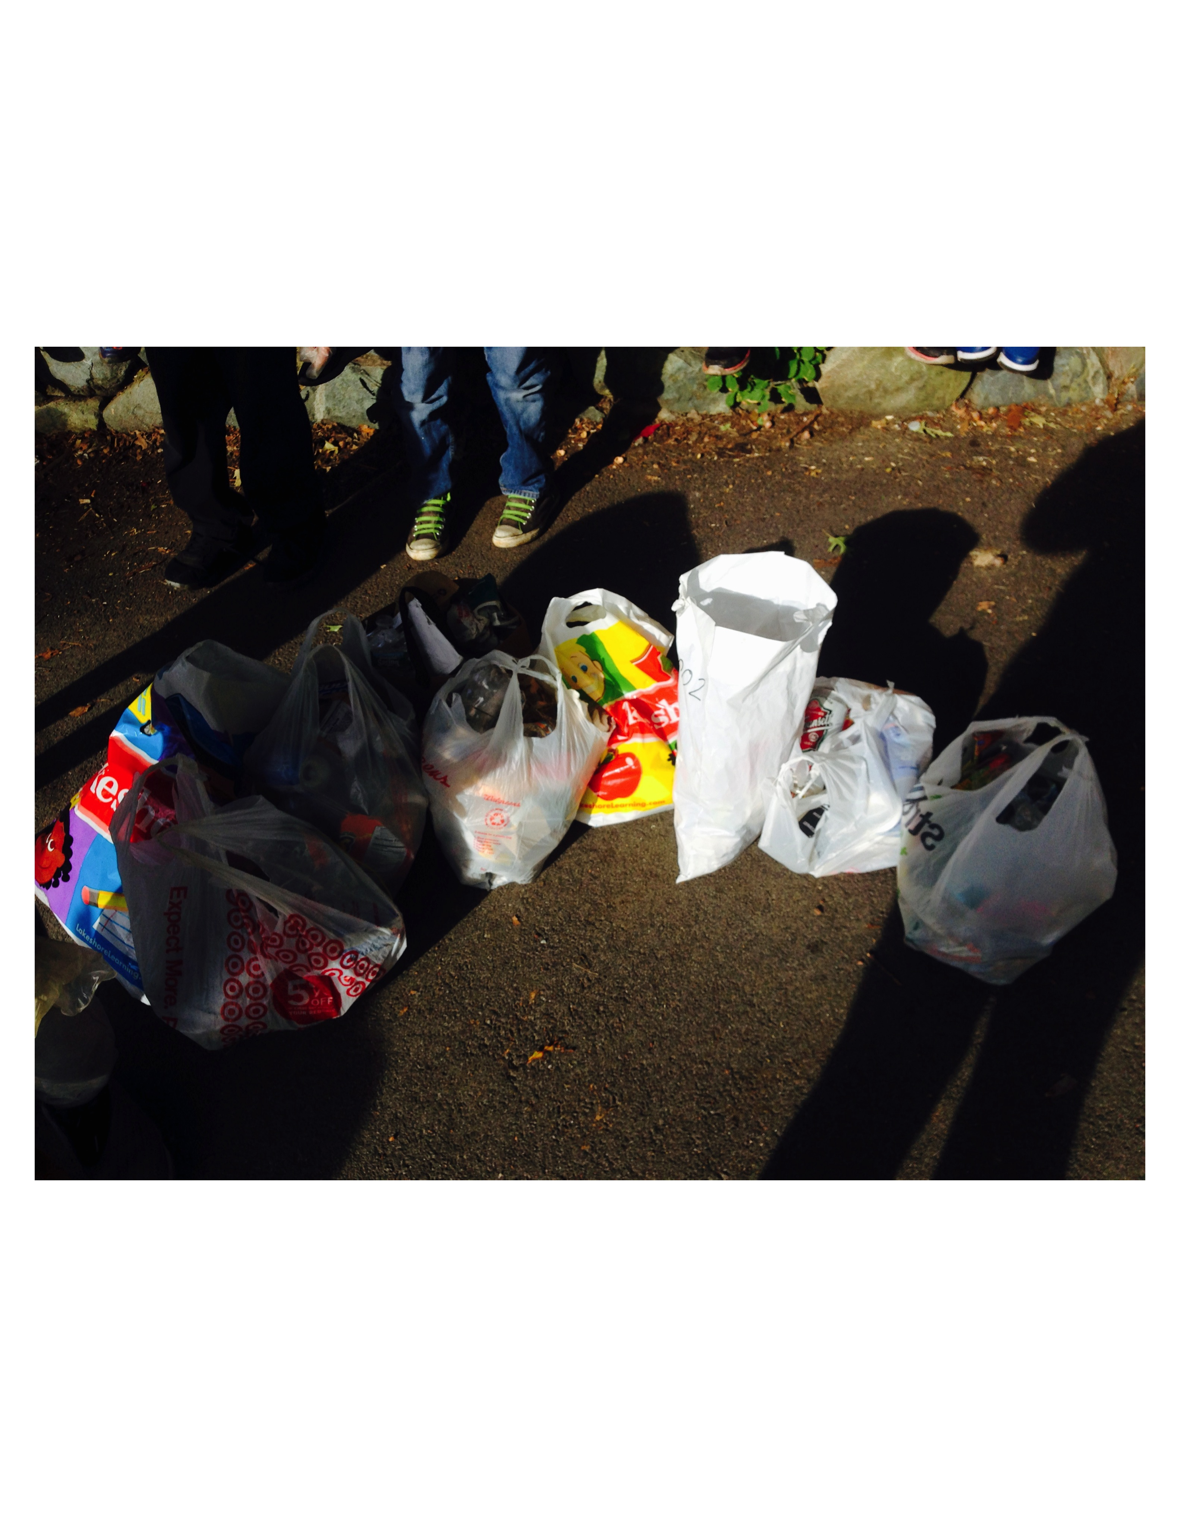ple.org](http://www.greenaple.org/)

**Franklin D. Roosevelt School**

**Principal Lynda-Lee Sheridan**

**Assistant Principal Bannet Steele**

Upper Campus: 95 Needham Road, Hyde Park, MA 02136

P: 617-635-8676

F: 617-635-8679

Lower Campus: 30 Millstone Road, Hyde Park, MA 02136

P: 617-635-9280

F: 617-635-9284

Please visit our website at **bostonpublicschools.org/roosevelt**

to find all general information about the school and classroom web pages.